**Exercise: Generate a visualization**

**Introduction**

Visualizations allow you to transform complex data into easily digestible and visually appealing charts, graphs, and maps, enabling you and your team to gain insights, and effectively communicate your findings. Visuals also aid stakeholders in reaching data-driven decisions. In this exercise, you’ll engage in the process of creating interactive visualizations using Microsoft Power BI for Adventure Works. By the end of this exercise, you'll understand how to import data into Microsoft Power BI, create interactive filters, and design different types of visualizations to effectively communicate insights and contribute meaningfully to data-driven decision-making.

**Case study**

Your manager at Adventure Works, Adio, hands you a comprehensive dataset containing information on sales, order statuses, and product performance from the past month. The company wants to understand its performance, identify growth opportunities, and streamline operations to remain competitive in the fast-paced outdoor gear market. As you start reviewing the dataset, you quickly realize that it's a large amount of data. It has hundreds of rows and columns. While the raw data holds valuable insights, its size makes it challenging to evaluate and difficult to communicate insights effectively to your team and stakeholders. This is where visualizations can help!

By using Microsoft Power BI, you'll be able to create a compelling and interactive dashboard to help Adio and the entire Adventure Works team better understand the company's performance and drive strategic decision-making. There is a wide range of core visualizations available in Power BI to help you display your data effectively.

**Instructions**

Create a new Microsoft Power BI project called *Exercise: Generate a visualization*. Follow the prompts below to complete the exercise.

**Step 1: Import data**

* Launch Microsoft Power BI Desktop to allow you to create the visualizations.
* Import the Adventure Works sales dataset called *Adventure Works sales dataset.csv.* This is the dataset you want to visualize.

[Adventure Works sales dataset](https://d3c33hcgiwev3.cloudfront.net/i4LNmR9pROuHP1JLs5i4ng_3652883b57554acc8bc5cac94f5dc5e1_AdventureWorks-sales-dataset.csv?Expires=1708732800&Signature=WdjJ7ah~WnCpYxCa8JUVTzsA8ThIJMOUYb2vQK1ritT1AHmZr~7qmv3XpNsz8J9DSewanKeOVegYPAkStfH0yNPGkTrd-DmDU1zP-H9JqQYpUxAE4C8dgI8F8cvGO2hELjKCfGAXaai~oIGq6i0cgWXueGkbeRtpHa8aUsOVKg4_&Key-Pair-Id=APKAJLTNE6QMUY6HBC5A" \t "_blank)

[CSV File](https://d3c33hcgiwev3.cloudfront.net/i4LNmR9pROuHP1JLs5i4ng_3652883b57554acc8bc5cac94f5dc5e1_AdventureWorks-sales-dataset.csv?Expires=1708732800&Signature=WdjJ7ah~WnCpYxCa8JUVTzsA8ThIJMOUYb2vQK1ritT1AHmZr~7qmv3XpNsz8J9DSewanKeOVegYPAkStfH0yNPGkTrd-DmDU1zP-H9JqQYpUxAE4C8dgI8F8cvGO2hELjKCfGAXaai~oIGq6i0cgWXueGkbeRtpHa8aUsOVKg4_&Key-Pair-Id=APKAJLTNE6QMUY6HBC5A" \t "_blank)

**Step 2: Create interactive filters**

One method for filtering data is a slicer—a visual tool that enables users to filter data interactively within a report.

* To add a slicer for the product category, on the **Home** tab, select **Slicer**.

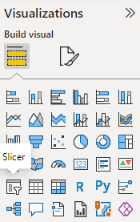

* Drag the **Product Category** field from the **Fields** pane to the slicer visual. This will create an interactive filter based on product categories.

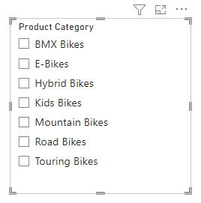

* Repeat the process to create another slicer, this time for the **Payment Method** field.
* For each slicer, add a title by selecting the **Format** tab and choosing **Title** from the options.

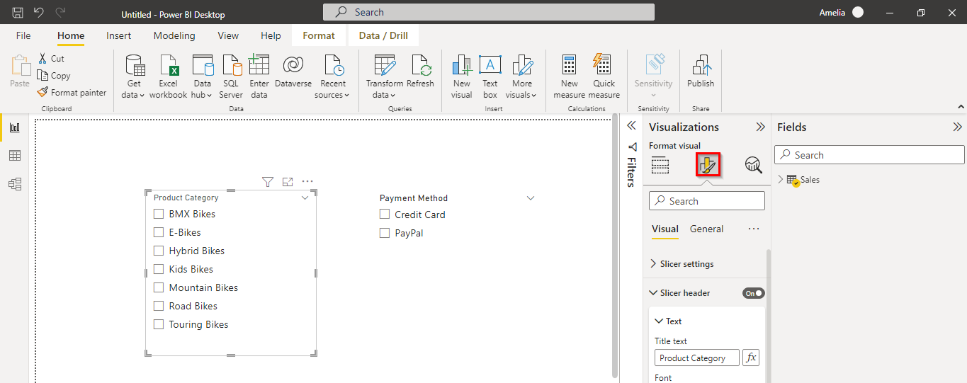

* Drag the positioning of the slicers to the right side of the report area.

**Step 3: Create a stacked column chart**

* Add a stacked column chart to your report. From the **Fields** pane, drag the **Order Total** onto the **Y-Axis**, **Product Size** onto the **X-Axis**, and **Product Category** onto the **Legend**.

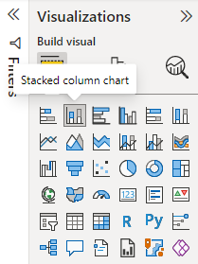

* Set the chart title to **Order Total by Product Size and Product Category for 2023**.
* Drag the stacked column chart visual to the left side of the **Report** area (next to the interactive slicer filters).

**Step 4: Create a donut chart**

* Add a donut chart for **Order Total Share** by **Product Category**.

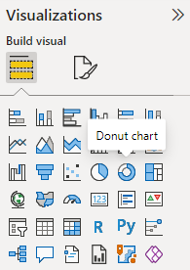

* Set the chart title to **Order Total Share by Product Category for 2023**.
* Drag the donut chart visual below the stacked column chart (created in Step 3).

**Step 5: Create a table**

* Add a table showing all product names with their corresponding order totals.

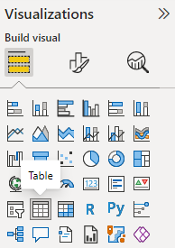

* Drag the table visual to the right side of the **Report** area, below the interactive filters (created in Step 2).

**Conclusion**

In this exercise, you created visualizations that transformed complex data by presenting it in a format that is easier to understand. By using the powerful features of Microsoft Power BI, you can create interactive and compelling dashboards that drive strategic decision-making within your organization.

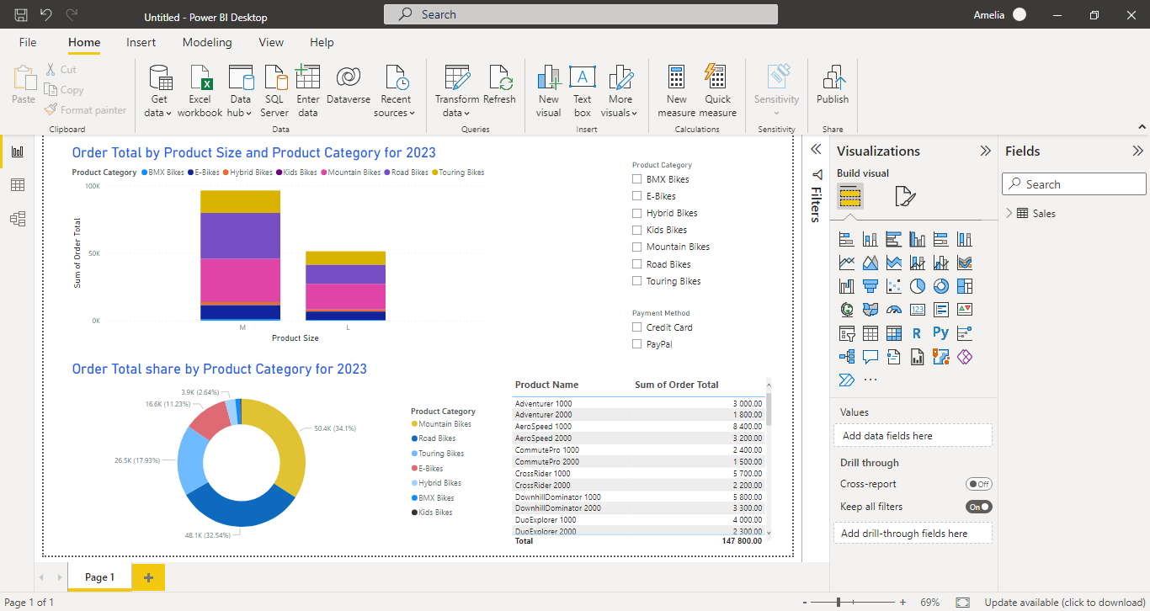

As you continue to develop your skills in data visualization, always remember that the ultimate goal is to communicate complex information in a simple, clear, and engaging manner, enabling everyone to make better decisions and drive positive change.

**Exemplar: Generate a visualization**

**Introduction**

In the *Generate a visualization* exercise, you were tasked with creating interactive visualizations in Microsoft Power BI to communicate insights simply and effectively. You used the Adventure Works sales dataset for this exercise.

The tasks you were asked to complete include:

* Create interactive filters by adding slicers for product category and payment method fields, and customize their appearance.
* Create a stacked column chart to show Order Total by Product Size and product category, and set a customized chart title.
* Create a donut chart for Order Total share by Product Subcategory, then customize the chart title.
* Create a table displaying the top 10 products by Order Total.

This reading provides you with an example answer guide that you can use to compare to your own work.

**Power BI Desktop user interface**

Power BI Desktop is updated and released on a monthly basis, incorporating customer feedback and new features. You might experience changes in the Power BI Desktop user interface (UI) that have taken place after the development of this training content. As a result, the screenshots in the videos, readings, or exercises might not align exactly with how you experience the UI. However, please note that these changes do not impact the functionalities of the UI. Hence, you will still be able to perform all the steps shown in that video, reading, or exercise.

**Exemplar: Generate a visualization**

**Step 1: Import data**

* To launch Power BI Desktop, you first needed to open Microsoft Power BI Desktop on your computer.

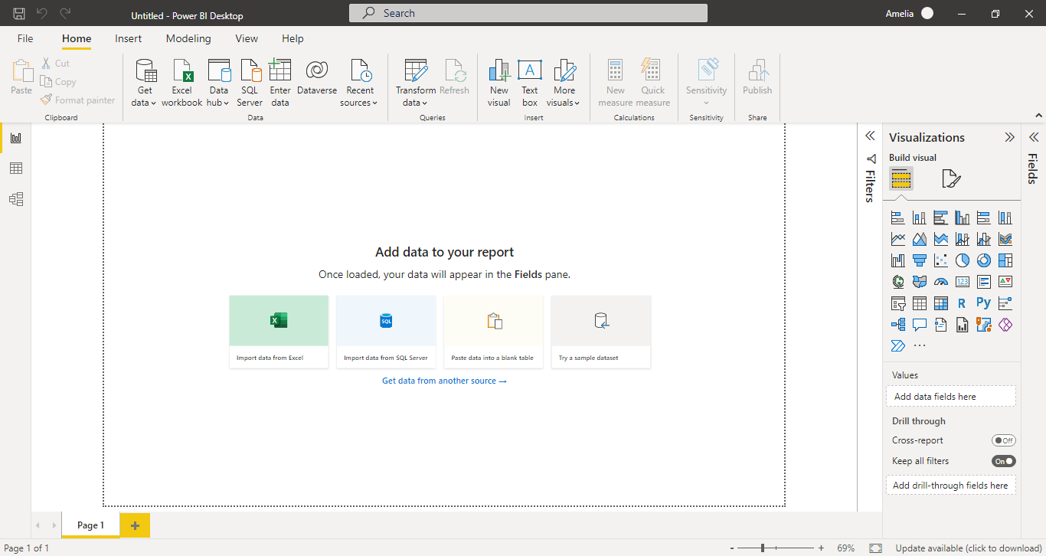

* Next, you needed to import the dataset you wanted to visualize (the Adventure Works sales dataset). You selected the **Home** tab, selected **Get Data**, and chose **Text/CSV** for the file type. Then you browsed to the location of your dataset and selected **Open** to import it.

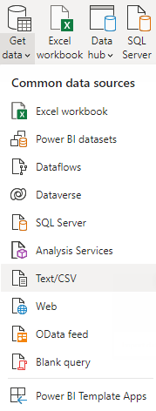

**Step 2: Create interactive filters**

* To add a slicer for product category, you selected the **Home** tab, followed by the **Slicer** visual.



* To add the fields, you dragged the **Product Category** field from the **Fields** pane to the slicer visual. This created an interactive filter based on product categories.



* Then you repeated the process to create another slicer, this time for the **Payment Method** field.
* You went on to customize the slicers by adding slicer headers. You did this on the **Format** tab by selecting **Title** from the options.

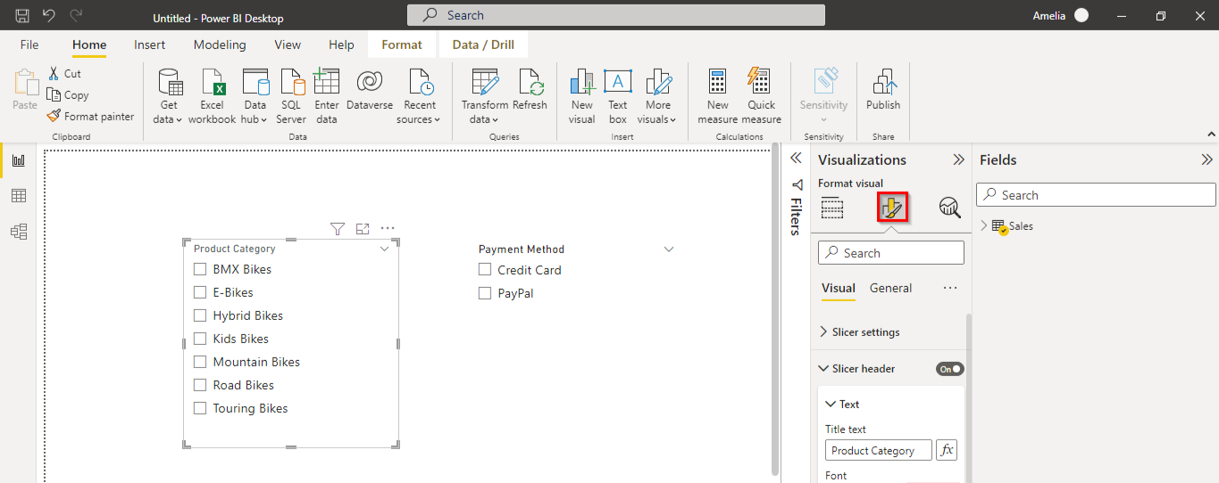

* To complete this step, you positioned the slicers by dragging them to the right side of the report area to keep them organized.

**Step 3: Create a stacked column chart**

* To achieve this, on the **Home** tab, you selected **Stacked Column Chart**.



* Next, you added the **Order Total** onto the **Y-Axis**, **Product Size** onto the **X-Axis**, and **Product Categ**ory onto the **Legend** from the **Fields** pane.

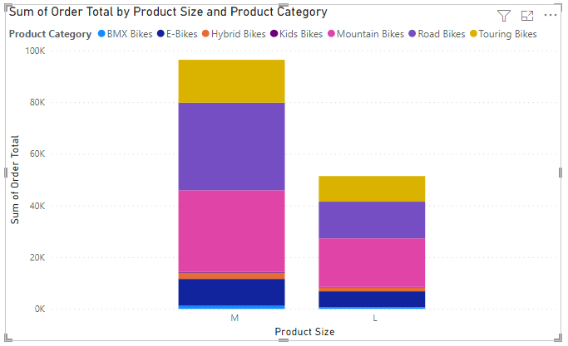

* After that, you set the chart title. You selected the **Format** tab and selected **Title** from the options. You changed the title to **Order Total by Product Size and Product Category for 2023.**

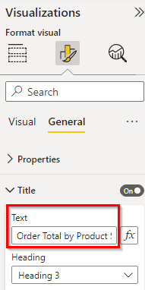

* Finally, you positioned the stacked column chart by dragging it to the left side of the report area (next to the interactive slicer filters).

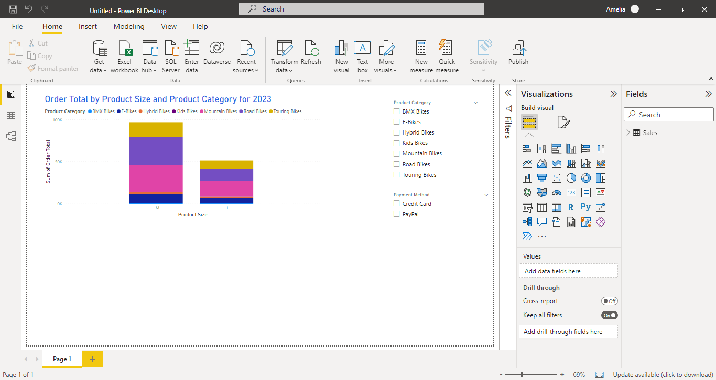

**Step 4: Create a donut chart**

* In this step, you added a donut chart using the **Donut Chart** visual on the **Home** tab.



* You then added the fields by dragging the **Order Total** field to the **Values** area within the visual and the **Product Category** field to the **Legend** area.

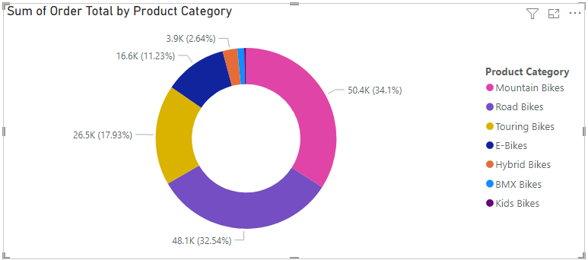

* Next, you set the chart title. You selected the **Format** tab, selected **Title** from the options, and changed the title to **Order Total share by Product Category for 2023**.

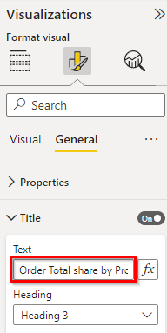

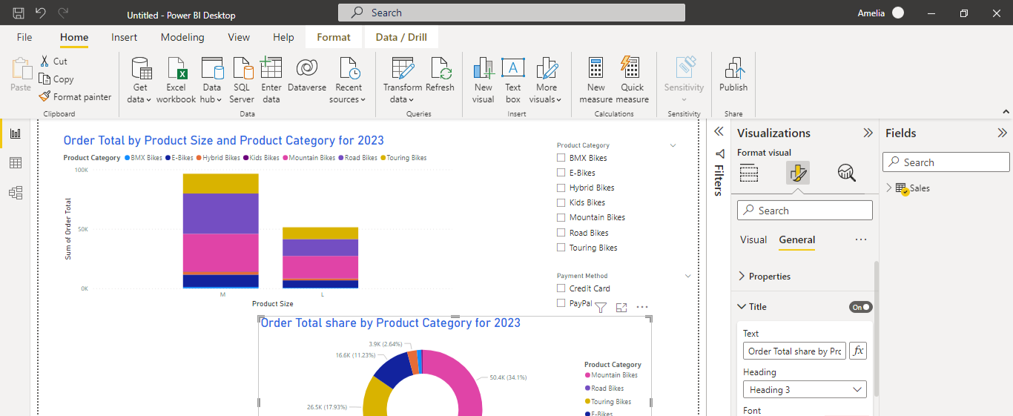

* To complete this step, you positioned the donut chart by drag it below the stacked column chart (created in Step 3) to ensure a visually balanced report.

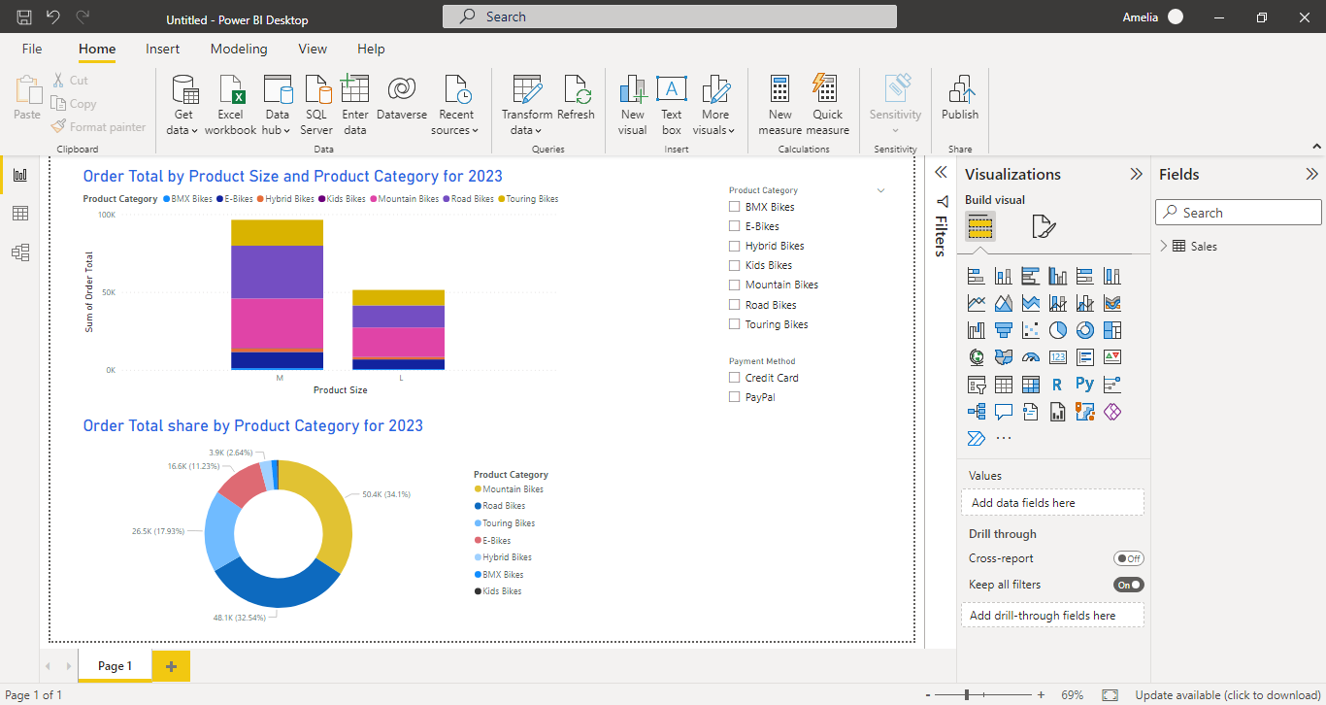

**Step 5: Create a table**

* To add a table, you selected the **Table** visual on the **Home** tab.



* Then you added the fields. You dragged the **ProductName** and **Order Total** fields from the **Fields** pane to the **Values** area within the visual.

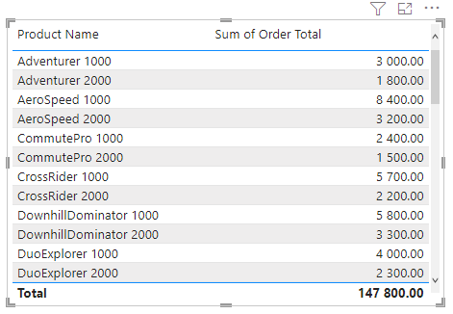

* Finally, you positioned the table by dragging it to the right side of the report area, below the interactive filters (created in Step 2).



**Conclusion**

The *Generate a visualization* exercise demonstrated the role data visualization plays in transforming large amounts of complex data into digestible, visually appealing formats that facilitate better decision-making and better communication of insights. By completing the exercise, you gained practical experience in Microsoft Power BI Desktop to generate interactive visualizations using a given dataset.